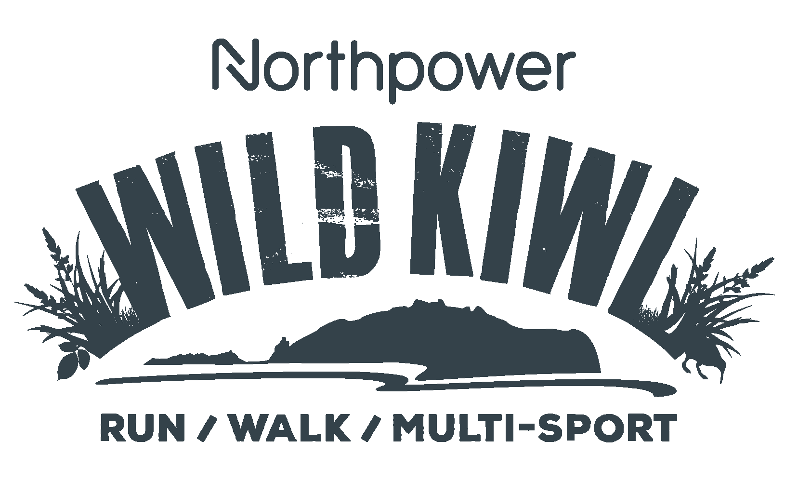

SCHOLARSHIP PROGRAMME
APPLICATION FORM 2023
What is it all about?
The Northpower Wild Kiwi Scholarship Programme is an amazing opportunity for you or someone you know to make a significant change in their health and wellness. With the goal of completing the 8km run or walk event at the Northpower Wild Kiwi on Saturday 11th March 2023.
The team at Activ8 Northland will guide you on a 6-week journey and will provide you with a training programme, regular bootcamp training sessions, and a Northpower Wild Kiwi Team shirt! Not to mention plenty of inspiration, motivation, fun and support along the way! Training sessions will take place each week as part of a bootcamp style session, starting early February 2023. It is expected that participants will be able to commit to attending the 1 weekly session for the 6-week bootcamp block, as well as other sessions and meeting with the group. More information is below.
Your coach will keep you accountable and focused as you work together towards your goals, however it will ultimately be up to you to put the work in. All of the group sessions will be located at or with the team at Actic8 in Whangarei. If you are a keen bean to make a change, then let's do this!
What does the Scholarship Programme include?
- An initial group meeting with Activ8 Northland to meet the other recipients and run through the items below
- 6 week training plan for each person
- 2 x bootcamp sessions per week for the 6 week duration
- Inclusion in a closed facebook group for support, to share runs, motivation and running tips
- An entry into the Activ8 8km run/walk at the Northpower Wild Kiwi
- A Northpower Wild Kiwi tee
It all starts here, please fill out the below and email it to markf@totalsport.co.nz before Monday 16th January. All applicants will be notified by 25th January as to whether they have been accepted into the programme and training will commence early February 2023.

Tell us about yourself (Information remains confidential)
Name:
Address:
Email:
Phone MB:
Phone Home:
Occupation:
In a typical work day, how many hours would you spend sitting (including transport)?:
Age:
Date of Birth:
Emergency Contact (name and number):
Do you smoke?
Are you pregnant / planning to be?
Which event do you plan to complete?
❏ 8KM walk
❏ 8KM run
Have you ever participated in the Northpower Wild Kiwi before? If so, when and which category?

Describe a typical week of activity/exercise currently:

What size Northpower Wild Kiwi tee would you order:

Of the following, please choose the top three areas where you would like to see significant
changes in your own health:
❏ Cardio Fitness
❏ Weight/Size
❏ Strength and/or Mobility
❏ Work-Life Balance
❏ Nutrition Habits
❏ Sleep Habits
❏ Stress Levels
❏ Chronic Health Issue
❏ Smoking
❏ Alcohol intake
Medical Conditions:
Have you ever, or do you currently suffer from any of the following:
❏ Sports injury
❏ Joint or bone problems
❏ Back problems
❏ Heart problems
❏ High/low blood pressure
❏ Stroke
❏ High cholesterol
❏ Diabetes
❏ Family member under 55 with any of the above
❏ Asthma
❏ Epilepsy
❏ Arthritis
❏ Pregnancy in the last 6 months
❏ Hernia
❏ Dizziness or fainting
❏ Surgery in the last 12 months
❏ Any other condition that may affect your ability to train
Please list_____________________________________________
❏ Are you on any medication that may affect your ability to train?
Please list_____________________________________________
WHAT IS YOUR OVERRIDING HEALTH AND WELLNESS GOAL FOR YOURSELF
IN THE NEXT 12 MONTHS? ie. What change do you want to see in yourself by January 2022?

Please return application by Monday 7th December and send completed form
and / or any questions to markf@totalsport.co.nz

